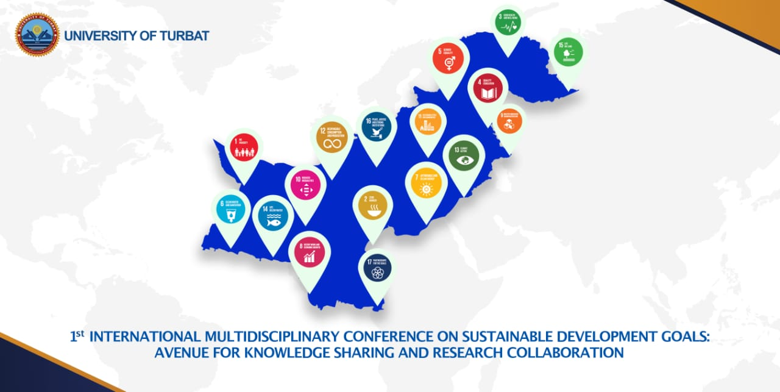

1st International Multidisciplinary Conference on Sustainable Development Goals: Avenue for Knowledge and Research Collaboration”
(1st IMCSDGs March 17-18, 2022)
Faculty of law, Faculty of science and engineering of UoT are collectively organizing a 2-days international conference entitled “1st International Multidisciplinary Conference on Sustainable Development Goals: Avenue for Knowledge and Research Collaboration” in collaboration with University of Sialkot (USKT) on March 17-18, 2021 at Law College Building, Turbat, University of Turbat, Balochistan– Pakistan.
1st International Multidisciplinary conference on Sustainable Development Goals: Avenue toward Knowledge and Research collaboration” (1st IMCSDGs - 2022) is considered to be an avenue for knowledge and research collaboration in deprived area Makran of Pakistan to gather international and national multidisciplinary experts and high-level practitioners to exchange knowledge, ideas, experiences and current research.
The main them 1st IMCSDGs Conference is to facilitate scientists, scholars, and practitioners to exchange new ideas and experience face to face discussions, to establish research relations and to find global partners for future collaboration from different region of country and around the world. This conference will help in exploring the worldwide emerging research and development in the Multidisciplinary fields. The event will provide an excellent platform for academics, policy makers, practitioners, researchers, industry experts and students, to share their work and experiences through the presentation and dissemination of high-quality research on topics relating to the areas of Environment, Applied & Basic Sciences and Modern Technologies, Health, Energy, Law & Justice, Economic, History and Archeology, Socio - lingua and Cultural heritage.
Special sessions, poster, and oral presentations will be included to the conference program. Prospective authors are kindly encouraged to contribute to and help shape the conference through submissions of their research abstracts, papers and posters in the domain of interest and are cordially invited for presentation at the conference.

Scope and Conference Topics:
1. The Interdisciplinary Research of Sustainable Development Goals (SDGs)
2. Pure and Applied Science
3. Engineering and Technology
4. Biological and Health Sciences
5. Humanities and Social Sciences
6. Environmental Engineering and Science
7. Hospitality, Tourism, Heritage
8. History, Archeology and Anthropology, linguistics
9. Law, Justice, Peace and Prosperity

Call for Abstract
Participants who are interesting to present paper/poster are requested to send their abstract (max. 300 words), title, authors’ name (name of presenting author underlined), affiliation, email and postal address along with duly filled registration form. Submissions must be original and should not have been published previously or be under consideration for publication while being evaluated for this conference. Submissions will be online through conference webpage and you also can Email your abstract at: imcsdgs@uot.edu.pk
Email ID for Correspondence:
University of Turbat,
Turbat Makran,
Website: www.uot.edu.pk
Email: drgulh@uot.edu.pk , drgulh@gmail.com
Prof. Dr. Gul Hasan
Cell Number: +92-3333-5191344
Tel: +92-852- 411778

1. Plenary Lectures, Keynote & Invited lectures (Hybrid mode)
On each day of the conference; plenary lectures of 40 minutes each will be followed by keynote lectures of 30 minutes each and this will again be followed by technical sessions with invited lectures of 20 minutes each. These lectures will be delivered by well-known Pakistani and foreign researchers.
2. Oral Presentation (Hybrid mode)
The invited lectures will be followed by oral presentations. The duration of the presentation during the conference will be 15 minutes with an additional 5 minutes for questions and answers.
3. Interactive Poster Presentation (on campus)
Dedicated poster sessions will be scheduled in the conference program.
Online Submission
Prospective authors are kindly invited to submit their formatted full papers including results, tables, figures and references. All submissions will be peer-reviewed and evaluated based on originality, research content, correctness, relevance to conference, contributions, and readability.
Note:
In case of any inconvenience for online submission please send your abstract / article on the
following email address / WhatsApp No. +92-333-5191344
Email: drgulh@uot.edu.pk

IMPORTANT DATES
Call for Paper | 10.12.2022
Last date of Abstract Submission | 30.01.2022
Acceptance/Regret Status of the Abstracts | 10.02.2022
Submission of Conference Presentation (PPTX) | 30.02.2022
Conference Date | 17-18,03.2022
Submission of draft Conference Paper | Post Conference

1st IMSDGs (2022)

Conference Sponsors

University of Turbat
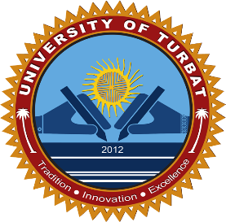

The University of Sialkot
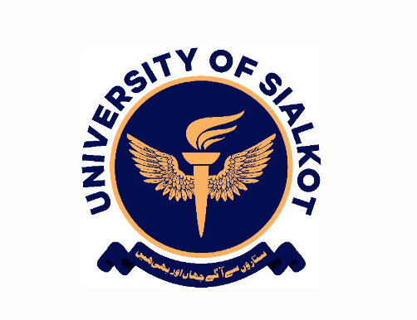
Balochistan Bar Council

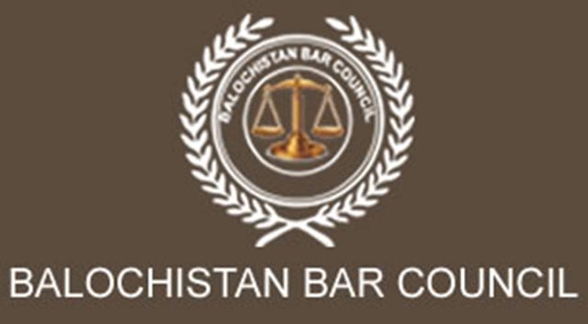

Conference Organizing Committee

Patron in Chief
Prof. Dr. Jan Muhammad
Vice Chancellor, University of Turbat, Balochistan, Pakistan
Conference Chair
Prof. Dr. Gul Hassan
Dean, University of Turbat, Balochistan, Pakistan
Conference Secretary
Dr. Naeemullah
Dean of Science and Engineering, University of Turbat, Balochistan, Pakistan
Dr. Haneef Ur Rahman
Associate Professor, Department of Natural and Basic Science, UoT
Conference Associates
Dr. Roohullah
Chairperson, Department of Natural and Basic Science, UoT
Dr. Muhammad Haroon
Assistant Professor, Department of Chemistry, UoT
Mr. Mukhtar Husain
Chairperson, Department of Computer Science, UoT
Mr. Sameer Ahmad
Assistant Professor, Department of Computer Science, UoT
Review & Publication Committee
Prof. Dr. Gul Hassan
Dean Faculty of Legal Education UoT
Dr. Muhammad Haroon
Assistant Professor Department of Chemistry, UoT
Dr. Iftikhar
Assistant Professor, Department of Botany, UoT, Panjgur Campus
Registration Committee
Dr. Roohullah
Chairperson, Department of Natural and Basic Science, UoT
Mr. Sameer Ahmad
Assistant Professor, Department of Computer Science, UoT
Dr. Muhammad Haroon
Assistant Professor, Department of Chemistry, UoT
Mr. Abdul Basit
Lecturer, Department of Chemistry, UoT
Organizing Committee
Mr. Ijaz Ahmad
DPR, UoT
Mr. Rashed Miandad
Graphic Designer
Mr. Junaind Qadir
Web Developer
Mr. Abdul Basit
Lecturer, Department of Chemistry, UoT
Fund Raising Committee
Treasurer Office
Registrar Office
Department of Law
Local Committee
Mr. Ghaus Bakhsh
Assistant Registar, UoT
Mir Bahad
Protocol Officer
Mr. Najamuddin
Lecturer, Department of Chemistry, UoT
Mr. Ateq Ur Rehman
Lecturer, Department of Chemistry, UoT
Mr. Mehrab
Campus coordinator
Purchase and Security Committee
Ayaz Bulaidi
Shahid Issa
Convener I.T / Networking Committee
IT and Computer Science Department
Mir Bahad
Protocol Officer

